
GARDE CITY UNIVERSITY

NAME : Haobijam Tejkumar singh
ROLL NUMBER : 25BTCE206
BRANCH BCS
COURSE NAME : CMAT
HANDS ON : 3
DATE OF ISSUE : 04/12/2025
DATE OF SUBMISSION :24/2/2026
SUBJECT : COMPUTATIONAL
MATHEMATICS
Handson session 3
1 .if a =x2Y+yz2thenfindV 20

Ans•. V 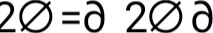 x2+ô 20/0 y2+ô 20/0 a
20/0 2xy = 2y
20/0 2yz=2y
V 20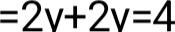
2.if a =sinx+cosy+z2 then findV 20

Ans:V 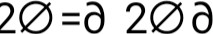 x2+ô 20/0 y2+ô 20/0 a
20/0 -sinx
20/0 -cosy
20/0 2
V 20 =-sinx +( -cosy )+ 2
3.if a =ex+y2+logz thenfindV 20
Ans: v 20=0 x2+ô 20/ô y2+ô 20/ô a
20/0 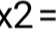ex
20/ô 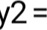2y = 2
20/0 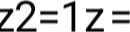-Iz2
v 20 = 0<+2-1 a
4. if =x3-3xy2 then show that is harmonic
Ans•. V 20=ô 20ô x2+ô 20/ô y2+ô 20/ô a
20/0 x2=6x 20/ô y2=-6x
20/0 z2=o v 20 , a isharmonic
5.if a =ex.cosythenfindV 20

Ans•. V 20=ô 20ô x2+ô 20/ô y2+ô 20/ô a
20/ô x2=ex 20/ô y2=cosy
20/ô z2=o
6.if a =x2-y2 then find V 20

Ans•.V 20=ô 20ô x2+ô 20/ô y2+ô 20/ô a
20/ô 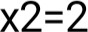 20/ô y2=-2 20/ô z2=o
7.find Laplacian of r = x2+y2+z2
Ans•. V 2r=ô 2rô x2+ô 2r/ô y2+ô 2r/ô a
ô rô x=1/2x2+y2+z2 = 2x = xr
applying d(u/v) = v.du - u.dv/vA2
20/0 r.l -x.ô rô x/r^{A}2= r -x. w / =
= r2-x2r/r2 = x2+y2/r3
2r/ô x2=x2+y2/r3 2r/ô x2+y2/r3
2r/ô z2=x2+y2/r3
V 2r=ô 2rô x2+ô 2r/ô y2+ô 2r/ô
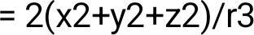
= 2r2/
= 2r
- Q)Find V if
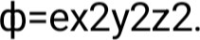
ANS:
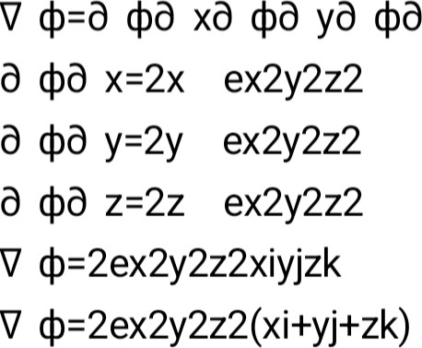 z
- Q)Find div F and curl F if
F=xy2 i+2x2yz j-3yz2 k.
ANS•.
div z(-3yz2) div F=y2+2x2z-6yz div F=y2+2x2z-6yz curl ijkö ö xö ö yö ö zxy22x2yz-3yz21 =i3z22x2y+k4xyz2xy curl F=(-3z2-2x2y)i+(4xyz-2xy)k
- Find div F and curl F if
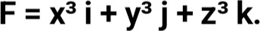
ANS:div z(z3) div F=3x2+3y2+3z2 div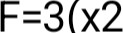
curl ijkô yô zx3y3z31 z3ô ya y3ô z-p z3ô x3ô z+kô y3ô
(0-0)-j 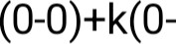curl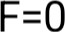
- Find the directional derivative of
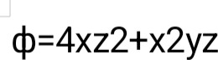
at the point 1 ,-2,1.
ANS:
V xö yö z x=4z2+2xyz y=x2z z=8xz+x2y
V 4)=(4z2+2xyz)i+(x2z)j+(8xz+x2y)k
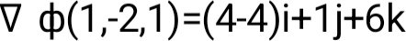
j+6k
12. lf ф = х²у+ yz², then find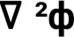
ANS•.V 2ф=д 2фё х2+ё 2фё у2+ё 2фё z2
д Фё д х(х2у)=2ху д 2фё х2=д д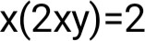
д Фё ё y(x2y+z2y)=x2+z2 д 2фё у2=о
д Фё д z(yz2)=2yz д 2фё z2=2y
2ф=2у+О+2у
2ф=4у

